SMART ENERGY METERING AND THEFT DETECTION SYSTEM

Documentation :-
Department : ECS
Date : 11/09/2025
Team Members :
A.DhanaLakshmi-24BCE8519
K.Dheeraj-24BCA7891
M.Chanakya-24BCA7839
S.Bhavya Sri-24BCE8375
P.Hiranmai-24BCA8149
K.Sri Lakshmi-24BCS7106

Introduction :

Electricity theft is one of the biggest challenges for power distribution companies. Traditional energy meters only record usage, but they cannot detect if someone is tampering with the connection or bypassing the meter.

To address this, we thought of designing a Smart Energy Metering and Theft Detection System. The project uses:

1.ESP32 microcontroller – the brain of the system.

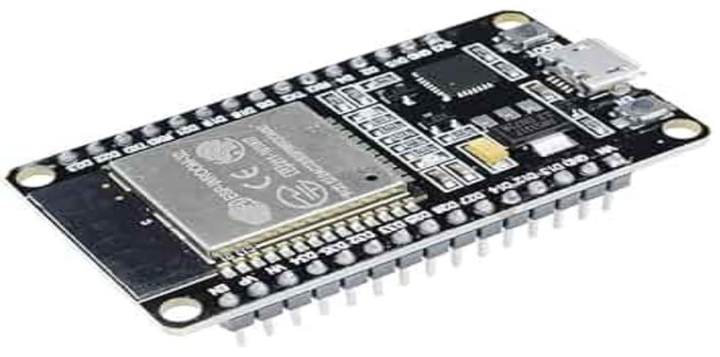

2.Current sensor – to measure current safely and accurately.

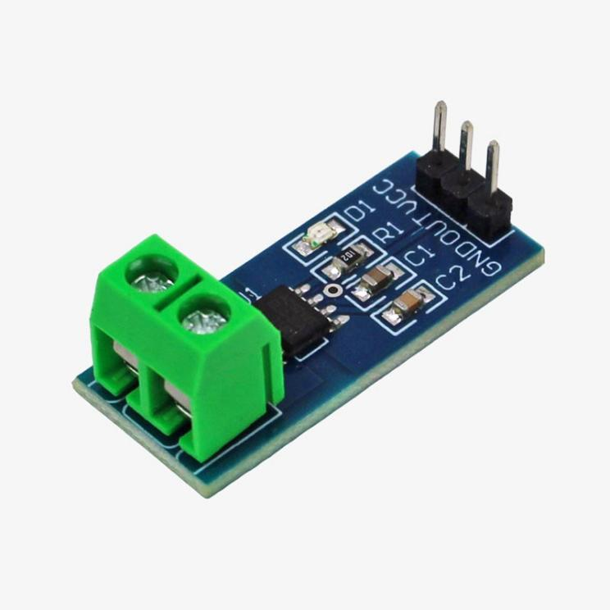

3.Voltage sensor – to measure voltage levels.

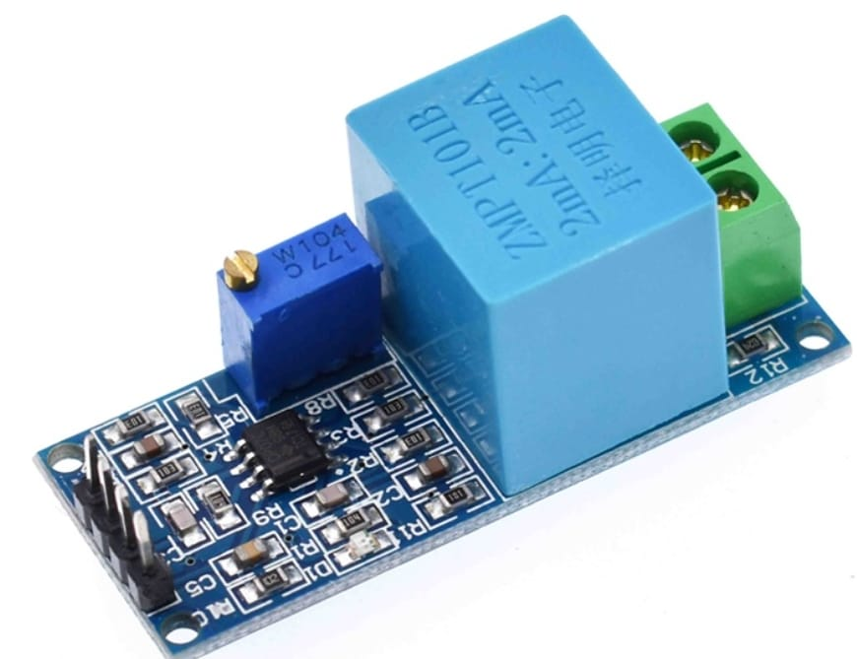

4.Relay module – to control the supply and disconnect it if theft is detected.

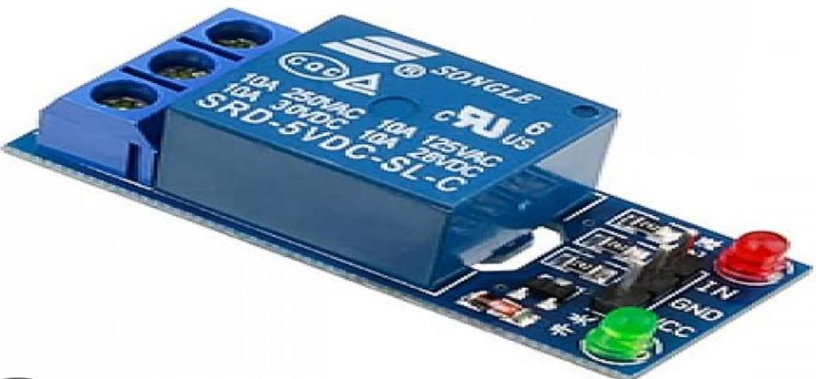

5.Hall effect sensor-to detect magnetic tampering and send instant signal to esp 32 which will cut the power supply by sending command to relay module.

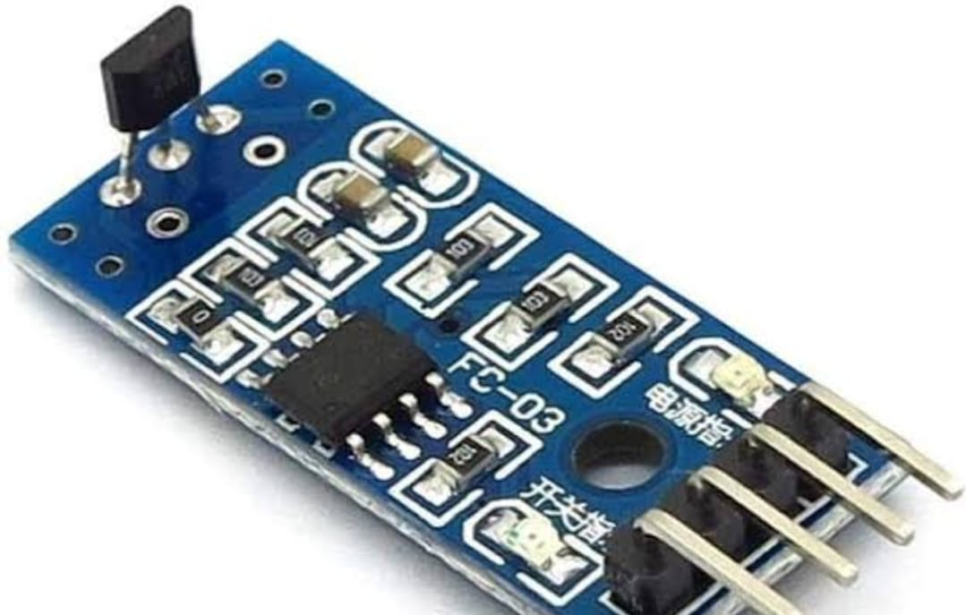

The system not only measures real-time energy usage but also checks for abnormal patterns that may indicate theft. If theft is detected, the relay cuts off the supply immediately, and the ESP32 can send alerts wirelessly.

This document covers both Review 1 (planning) and Review 2 (implementation) stages of the project.

Review 1 – Planning Stage

During the planning stage, we focused on the concept and preparation.
We identified the problem: energy theft and lack of monitoring in traditional meters.

*We decided to use ESP32 because of its fast processing power and Wi-Fi connectivity.

* We chose the Hall effect sensor, which detects the magnetic field around and sends instant signals to esp32 which sends commands to rely module for automatic disconnection.

*A voltage sensor was planned for measuring voltage levels.

*A relay module was added to cut the power supply automatically if theft is detected.

*A budget estimate was prepared, and the project was found to be cost-effective.

*Responsibilities were divided among the team.
By the end of Review 1, we had a clear roadmap for implementation.

Review 2 – Implementation Stage

After the planning, we moved on to hardware setup, coding, and testing.

Hardware Progress:

*The ESP32 was connected to the laptop via Arduino IDE.

*The voltage sensor was connected and tested.

*The relay module was added to control the supply. When theft is detected, ESP32 commands the relay to cut off the line.

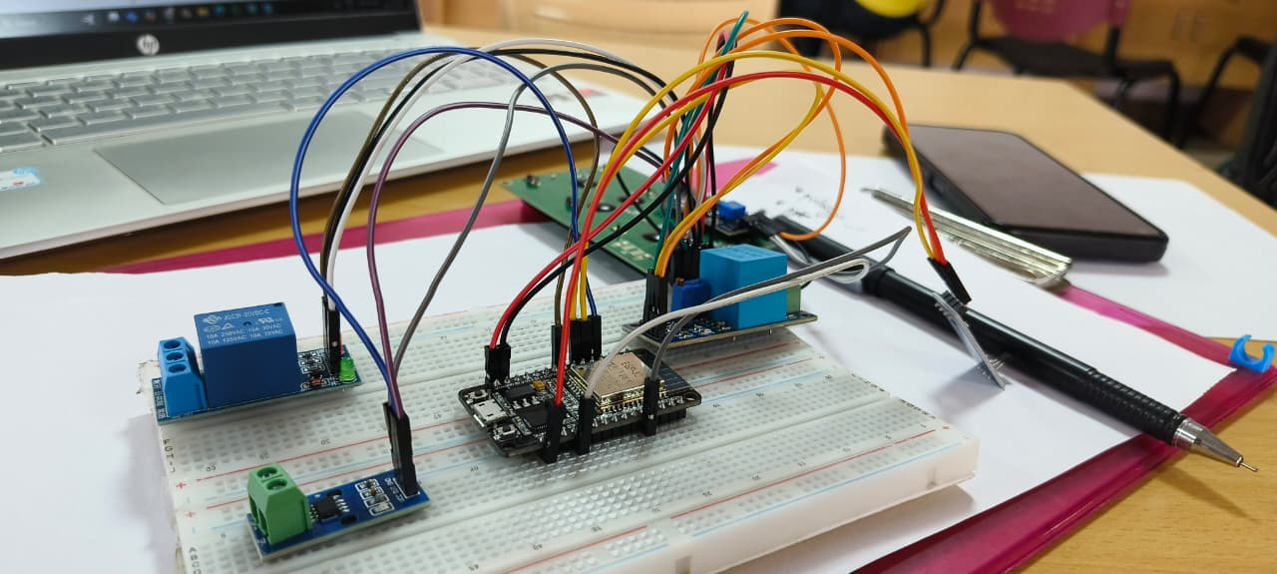
All these setups were carried out on a breadboard, not a PCB (since this stage was mainly for testing and verifying the concept).
Software Progress

Software platform is ready for coding . The program does the following:

*Reads current using the Current sensor.

*Reads voltage using the voltage sensor.

*Calculates real-time power and energy consumption.

*Detects theft if abnormal usage patterns are noticed.

*If theft is found, sends a command to the relay module to disconnect supply.

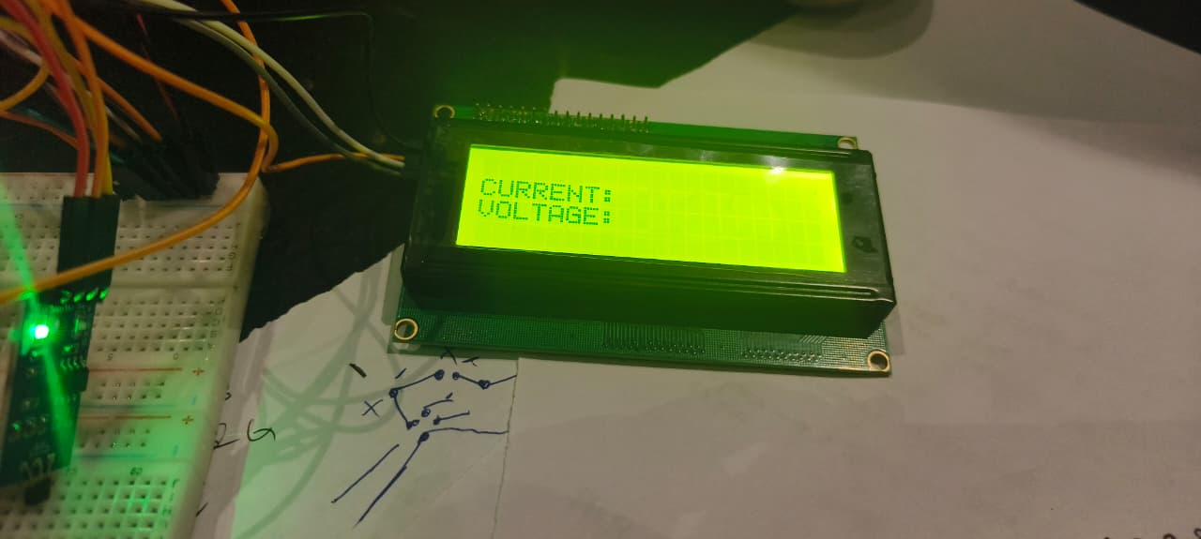
Core Functionality and Working

1. Normal Operation
*Sensors measure current and voltage.
*ESP32 calculates power and sends usage data wirelessly.
*Relay keeps the supply ON,it sends live current and voltage readings to the electrical department and user ,so that they can access in Blynk IOT platform.

2. Theft Detection
*If ESP32 finds mismatched readings or abnormal current flow, it marks it as theft.
*ESP32 immediately signals the relay to disconnect the power line.
*A warning/alert is sent to the electrical department if any theft is detected.

Thus, the system ensures both monitoring and automatic theft prevention.

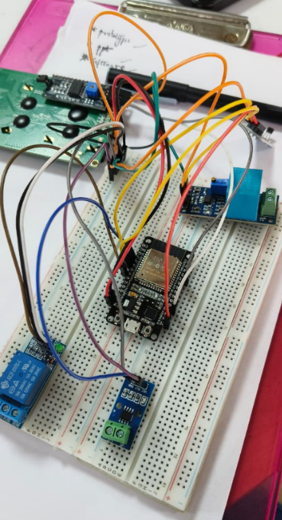

Team Efforts
Three of the team members Bhavya , Chanakya , Hiranmai had put major efforts in buying some of the major components offline .
Slip is given below:

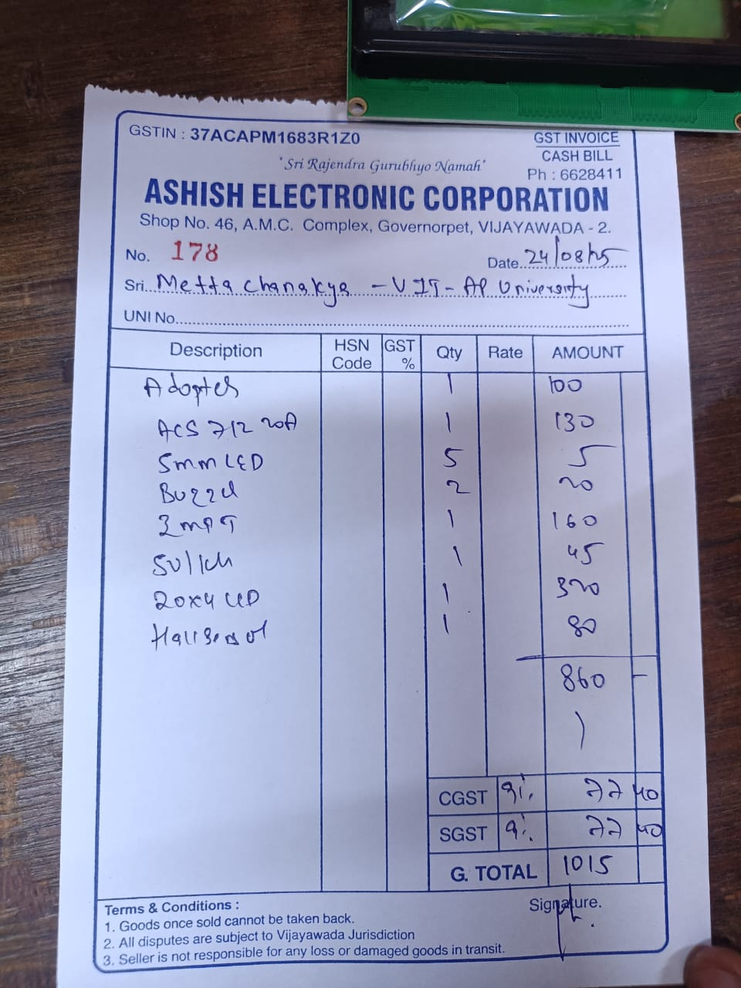

We purchased some of the components online like ESP32, I2C and bulb(load).

This project was possible only because of the combined effort of all six team members. Each of us took up specific roles, but we also worked together and supported one another whenever challenges came up.

Dheeraj and Chanakya focused mainly on the hardware assembly. They carefully connected the ESP32, Hall effect sensor, voltage sensor, and relay on the breadboard. Their neat wiring and patience during repeated testing made sure the circuit worked without loose connections.

Bhavya and Dhana Lakshmi worked on the software side. They are currently working on writing the Arduino IDE code for the ESP32, including the logic for power calculation, theft detection, and controlling the relay. Even when errors showed up in the code, they stayed persistent until the program worked smoothly.

Sri Lakshmi and Hiranmai managed the documentation and budgeting. They kept track of all expenses, prepared the Review 1 and Review 2 reports, and made sure every detail of the project’s progress was clearly recorded. Their effort ensured that our work was always well-documented.

Dhana took up the role of coordinator and tester. She organized team meetings, made sure tasks were on track, and led the testing sessions. By noting down issues and helping troubleshoot them, they kept the whole project moving smoothly.

What made our teamwork special was that no one worked in isolation. For example, while Bhavya coded, Hiran and SriLakshmi were right beside her helping her out whenever necessary . This spirit of collaboration of Dheeraj and Chanakya turned our idea into a working prototype.
We held regular meetings to:
*Study the working of the Hall effect sensor, relay, and voltage sensor.
*Shared tasks between coding and circuit design.

Challenges Faced
*ESP32 communication setup took extra time.

*Installation of libraries for software took extra time due to network issues.
But through teamwork, these issues were resolved.

*Esp32 can only handle a voltage up to 3.3 volts while the analog output voltage signal received from the components is at 5 volt. Hence a step down , power regulator is being used to convert the 5 volt output to 3.3 volts before it enters the esp32 microcontroller

In Review 1

*we prepared the concept, selected ESP32, Hall effect sensor, voltage sensor, and relay, and made a roadmap.

In Review 2

*We Built and tested the system on a breadboard.
*Completed the analysis of software part by setting up the platform.
When we look back at where we started, it’s clear how far we’ve come as a team. In the beginning, during Review 1, all we had was an idea — a smart energy metering and theft detection system. We spent hours discussing what components we would need, how the system should work, and how to divide the tasks. It was all planning and imagination at that stage.

By the time we reached Review 2, things became real. We sat together, connected the ESP32, Hall effect sensor, voltage sensor, and relay on the breadboard, and wrote the code in Arduino IDE. Sometimes the working didn’t respond the way we expected, but instead of getting stuck, we worked through it together. Slowly, the system came to life .

Right now, our prototype is fully working on the breadboard. The next big step is to move everything onto a PCB and polish the system so it looks and works like a complete product. That will be our main focus for Review 3.

